**FACULTY OF ENGINEERING AND NATURAL SCIENCES**

**ENS 209**

**INTRODUCTION TO COMPUTER AIDED DRAFTING & SOLID MODELING**

**TERM PROJECT PROPOSAL**

**“WIND-UP TOY CAR”**

Prepared by:

Ufuk Ulaş Tokat 28914

Okan Arslantaş 26345

Çise Göksu Uzun 28502

Begüm Boynukısa 27052

Supervised by:

Utku Seven

**Introduction:**

Wind-up toy car is an automaton toy car which is powered by a clockwork engine (Wulffson, 2022.) Automata produced for the purposes of art, entertainment, and simulation have been seen, with examples include Heron of Alexandria creating clockwork birds during the Hellenistic Period. It is commonly said that Leonardo da Vinci invented the mechanical lion that he gave to King Francois I in France in the 16th century. The Château du Clos Lucé has a replica of this mechanism even if the original drawings are lost to time (Shirbon, 2009).

They work by storing the movement of the rotating wheels as energy in a helical spring inside the large central toothed wheel after the car is pulled back while being pushed down. When released, it will unwind and move the car ahead. A clutch disengages once the spring has completely sprung, allowing the machine to roll free (Sorrel, 2011).

**Detailed Description of the Product:**

1.Wind up Motor.

Our project is a wind-up toy car. It will have 4 tires, one wind-up motor that is formed by 8 unique parts, and cosmetic parts that will form the body of the car. Parts can be listed as gearbox including 5 different gears, 2 main shafts, 1 medium shaft and 1 arc. All parts will be designed on Solidworks and will be printed from a 3d printer. The material that will be used is PLA. Purpose of this project is to create a toy for children and adults who always remains as a child. It will be a toy car that can be set by moving it back to go forward. Wind up motor will look different than the manufactured ones (picture 1.1) but the working principle will be the same. To visualize the final product picture 2.1 and 2.2 are given.

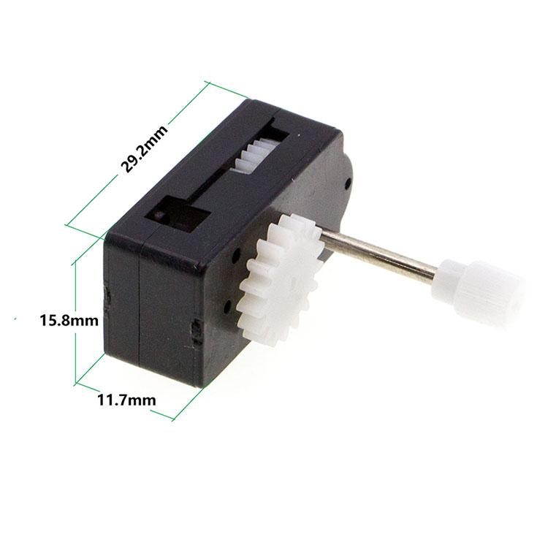

Picture 1

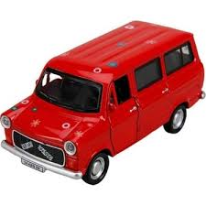

Picture 2.1

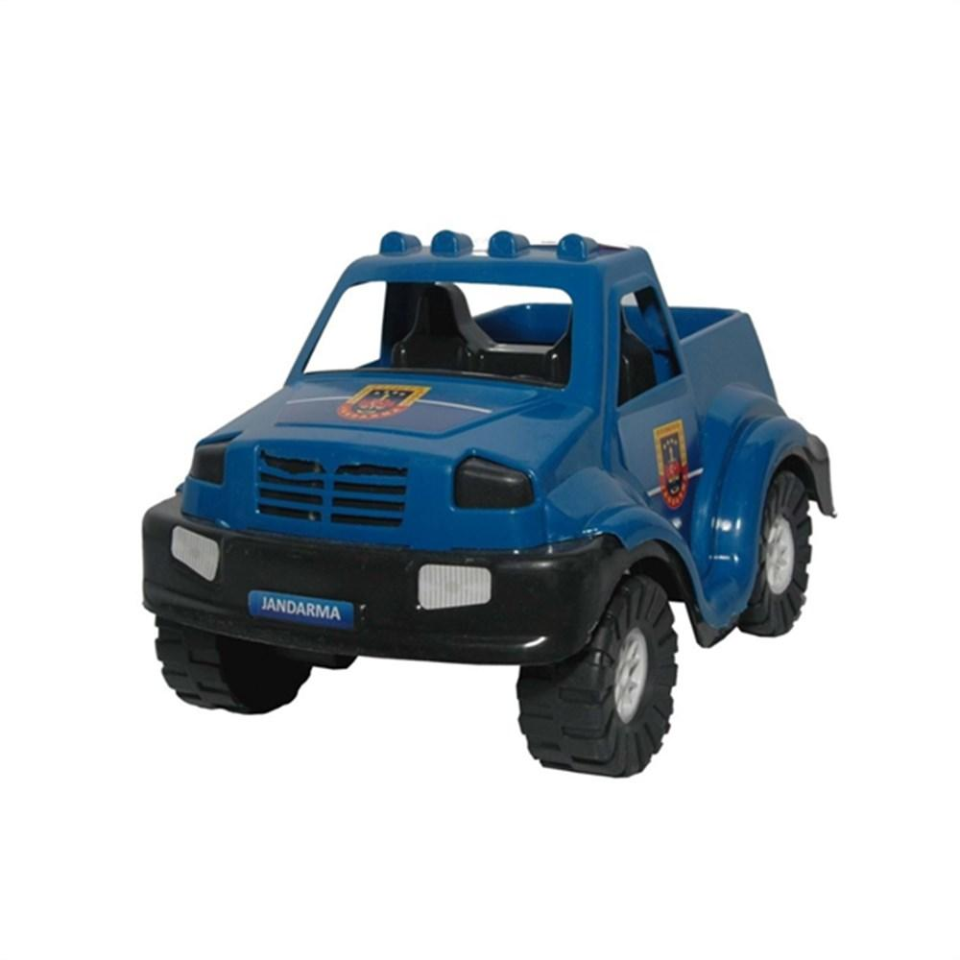

Picture 2.2

**Market:**

Since wind-up toy cars are a very specific type of product, there isn’t any publicly available market research. Due to that, a broader market research was conducted. This market research includes the global toy market and the global toy car market.

According to Roshan D. (2022) toy car market segmented as types, application and region. Tpyes include metal, plastic and others; applications segmented as family and kindergarten; region covers North America, Europe, Asia-pacific and LAMEA. Key market players highlighted as Hasbro, Amalgam, Mattel, Lego, Bandai and looksmart.

D. Tighe (2021), shows that retail sales of toy vehicles in the United States is nearly 1.55 billion U.S. dollars in 2020 and 1.34 billion in 2019, 1.46 billion in 2018 and 1.56 billion in 2017.

Study on the competitiveness of the toy industry (2013) anticipated that sales of traditional games and toys will exceed 1 billion euro in Europe, 0.9 billion euro in US and 0.5 billion euro in china. In 2011 sales of car and construction toys had a 12% market share in Europe, %9 in US and %13 in China and they are demanded mostly by the 0-14 age group. Main players on the toy market are Mattel, Lego, Hasbro, Private Label, Simbia-Dickie group and Vtech Holding.

**Time table:**

| **Work** | **Week** | **Member** |
| --- | --- | --- |
| Market research, Project Proposal | 1-4 | All team members |
| 3D Sketching of different gears | 5-8 | Begüm Boynukısa, Ufuk Ulaş Tokat |
| 3D Sketching of shafts | 5-8 | Okan Arslantaş |
| 3D Sketching of arc and tires | 5-8 | Çise Göksu Uzun |
| Project Progress Report | 8 | All team members |
| 3D Drawing of components | 9-12 | All team members |
| Assembling of all components | 12 | All team members |
| Project Final Report | 12 | All team members |

**Resources:**

<https://www.statista.com/statistics/247415/toy-sales-in-the-us-toy-vehicles/>

<https://www.alliedmarketresearch.com/toy-cars-market-A15020>

DG Enterprise and Industry (2013), Study on the competitiveness of the toy industry, ECSIP consortium.

<https://archive.md/20121209181102/http://webcache.googleusercontent.com/search?q=cache:zCaydYvRE2oJ:accelerateu.org/assessments/ELA6/WindupToys.doc+How+do+Wind+up+toys+work&hl=en&ct=clnk&cd=1&gl=us>

<https://www.reuters.com/article/us-france-davinci-lion/da-vincis-lion-prowls-again-after-500-years-idUSTRE57D1MQ20090814>

<https://www.wired.com/2011/04/its-a-wind-up-gorgeous-spring-powered-toy-car-not-for-kids/>